**Prompted to change your NCEdCloud Password**

Your INITIAL NCEdCloud password is Hawks1234. You MAYBE prompted to change your password. PLEASE make sure you write down your NEW password and keep it in a safe and accessible place like a notebook or notecard. Follow the below instructions when creating a NEW password. If you loss the password you created please contact one of your teachers by email to have them reset it. Teacher emails are located on the school website located under the Staff tab and Staff Directory. If you ARE NOT using a GCS device use the my.ncedcloud.org site.

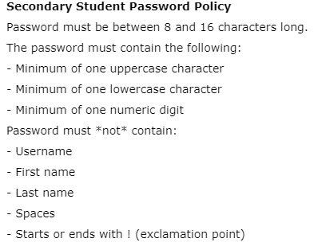

**NCEdCloud Survey**

Your student MAY or MAY NOT be prompted to complete a NCEdCloud survey. If you CAN NOT answer the question in 3 seconds just type none. The answers to these questions are not needed for anything for the student’s access to NCEdCloud.